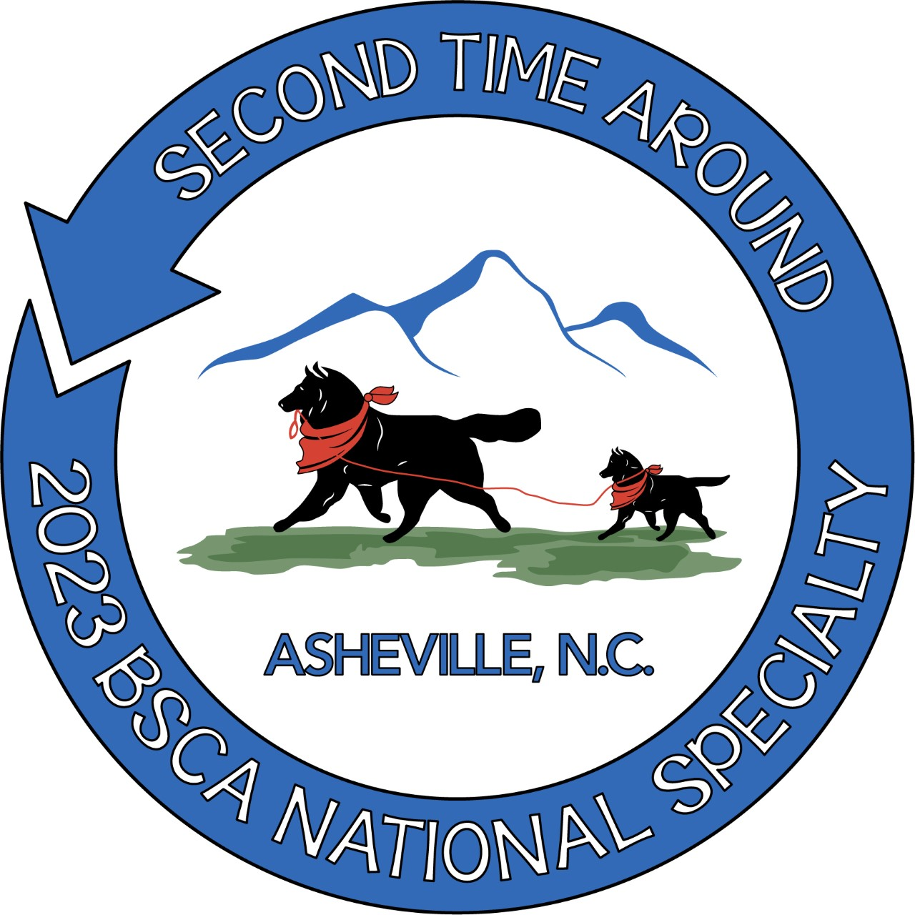

BSCA NATIONAL SPECIALTY
RESERVATION FORM

RV PARKING

RV Parking is by Pre-paid reservation ONLY

Parking fee is $30 per day with a 4 day minimum

Return this completed form AND check payable to BSCA to:
Sherry Hanley
6229 Venture Court
Slatington, Pa 18080

NAME_________________________________________________________________

ADDRESS______________________________________________________________

CITY/STATE/ZIP_______________________________________________________

PHONE NO (DAY)_____________________CELL____________________________

EMAIL________________________________________________________________

TOTAL LENGTH OF VEHICLE__________________________________________

TYPE- MOTOR HOME/TRAILER/SLIDES_________________________________

LICENSE PLATE NUMBER______________________________________________

ARRIVAL DATE___________________DEPARTURE DATE___________________

/TOTAL NUMBER OF DAYS_________________________

SPECIAL REQUESTS____________________________________________________

Deadline is March 22, 2023

***You will receive an email confirmation

